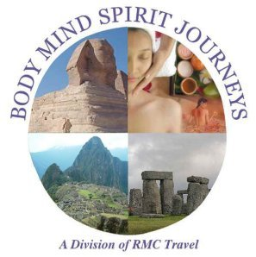

InnerQuest

Christian Metaphysical Experience in Turkey
September 14th – 22rd, 2011
Day 1., Wednesday, September 14: Atlanta to Turkey
Depart on your international flight to Istanbul
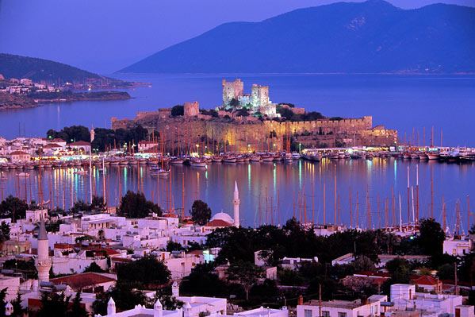
Day 2. Thursday, September 15: Arrive Istanbul / Welcome Dinner (D)
Arrive in Istanbul, local time. Upon we go through Immigration, claim our luggage and exit through Customs. We will be met by our local tour representative who will transfer us to the hotel. Time to rest and relax. Meet in the hotel lobby and directed to the room for our Welcome Dinner at the hotel.
Overnight Istanbul. Hotel Eresin Taksim or similar
Day 3. Friday, September 16: In Istanbul: Full day tour (B,L)
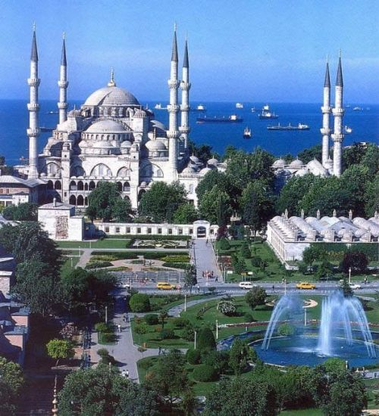
Depart to visit the famous Blue Mosque, with its mighty dome, and the only mosque in Istanbul with minarets. This was built on the site of the Great Palace of Byzantium in the early 17th century. Today it is a working mosque and is therefore closed to non-worshippers during the five daily prayers. The interior, with its lightness, spatial effect and color, is one of the finest creations of Turkish architecture. Next is the St. Sophia Museum, formerly known as the Hagia Sofia (Holy Wisdom), a former Greek Orthodox church that was converted to a mosque in 1453 by the Ottoman Empire. This is e supreme achievement of Byzantine architecture, and it’s the city's most celebrated monument. Large numbers of columns were brought to Constantinople from temples in Asia Minor, Lebanon, Greece and Italy, and the finest marbles and noblest metals were used. We then visit the Archeological Museum, which contains an important collection of prehistoric Greek, Roman and Byzantine antiquities. In the courtyard is the graceful Tiled Pavilion, one of the oldest surviving Turkish buildings in Istanbul. Lunch included in the tour, then it’s back to touring the city, and maybe even pick some of our own sites… You’re in Istanbul Turkey, one of the richest historical cities on the planet, there is plenty to explore and enjoy. Overnight Istanbul.
Day 4. Saturday, September 17: To Cappadocia (B/D)
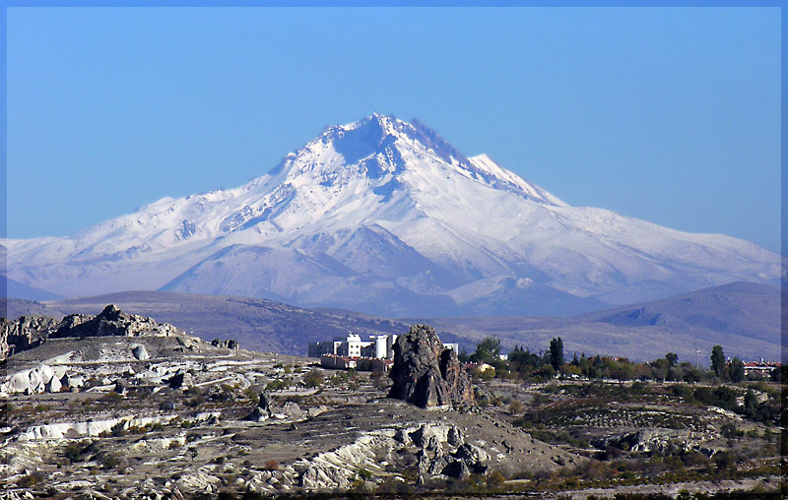
Early morning breakfast at our hotel and then we’ll transfer to the airport for the flight to Kayseri. Upon arrival, our coach will meet us and we’ll continue to Cappadocia. This will be a full day of touring, highlighted by our visit to the rock carved cities and surrealistic landscapes where nature has sculpted the earth into fantastic shapes, rock cones and fretted ravines including some of the dozen rocked-carved churches that were painted with exquisite frescoes by early Christians more than a 1,000 years ago. Highlights will be a visit to the cave of Goreme and the Byzantine churches of the area as well as the underground city of Kaymaki, where early Christians feeling persecution lived undetected for months at a time. Return to our hotel for dinner and overnight Overnight Cappadocia. Hotel Perissia or similar

Day 5. Sunday, September 18, Fly to Izmir and touring Pergammon. Onto Kusadasi (B/D)
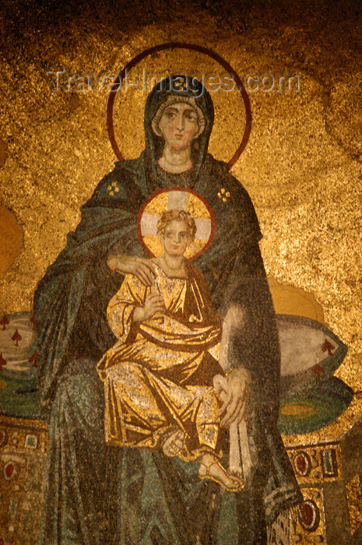
A early morning flight via Istanbul to Izmir. Departure at 6:30am Upon arrival we board our coach and continue to Pergamon for a full day of touring, and to visit the ancient Temples to Athena, Isis and Serapis. Our visit here will include both the Isis and Serapis Temple at the bottom of the hill, as well as the area of the site at the top of the hill. Much to explore! Located on the fertile plains watered by the Selinus River, Pergamon was home to
many civilizations in ancient times. Its Greek name means "citadel." Pergamon – this is a very energetically this site is very important to us because of all the healing work that was done here at the healing /complex. Then we’ll continue on to explore the Acropolis; Asclepion (Sanctuary of Aesculpius). Continue on to the Temple of Zeus; Trojan Temple; Temple of Dionysus, Temple of Athena; Alexandria Troas if possible. We end our day in Kusadasi, situated on the west coast of Turkey, and reputed to be one of the most attractive cities of the Aegean. Overnight Kusadasi at the Hotel Tailises or similar

Day 6, Monday, September 19: Excursions to Ephesus, Didyma, Miletus & Prienne (B/L):
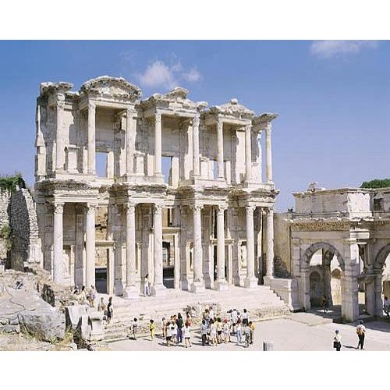
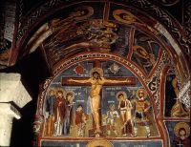
An early breakfast as we depart for a very full-day of touring, beginning at Ephesus to explore this powerful ancient city. Then it’s on to Temple of Apollo at Didyma (Didim in Turkish) was among the most famous oracles in the ancient world, equal in importance to the oracular temple at Delphi in Greece. It's the southernmost of the three ancient sites (Priene, Miletus and Didyma) There has been a temple here since very early times, but the older structure was destroyed by Cyrus of Persia in 494 BC. Construction began on the present stupendous structure soon after. The Didymaion, as it was also called, was reached by a Sacred Way from the harbor of Panormus. The huge white-marble temple is simply amazing, with a forest of 120 giant columns at the front porch. At the back of the porch, temple priests met petitioners in a huge portal to accept questions for the oracle, and to deliver oracular poem. Miletus, near the coast of western Turkey, was one of the most important cities in the ancient Greek world, but eventually declined due to the silting up of its harbors. St. Paul stopped at Miletus on his Third Missionary Journey, on his way back to Jerusalem. We will view many of the well-preserved ruins to be seen at the site, including a Temple of Apollo, a Byzantine church, and an important inscription relating to Jews. A stop in Prienne on the way back to our hotel. Overnight Kasadasi – Hotel Tailses of similar

Day 7, Tuesday, September 20: To Pamukkale and Denizili (B/D)
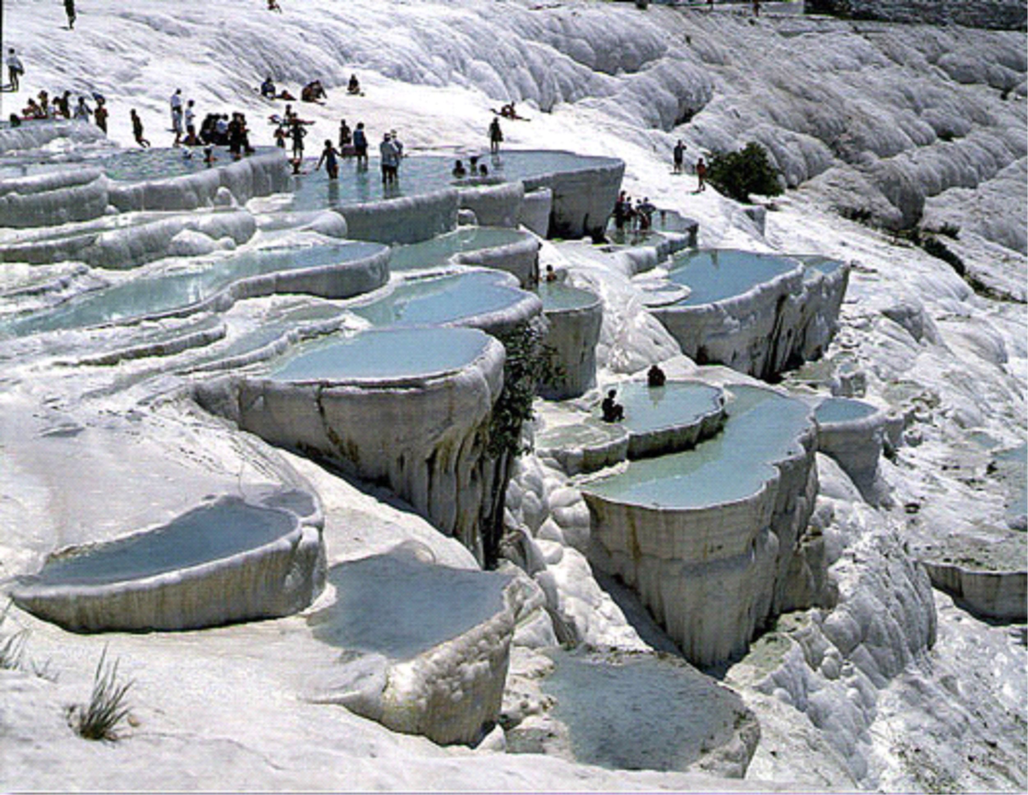
After breakfast, we continue to Pamukkale (with a visit to Aphrodisia along the way. Here we’ll visit the city of Hierapolis (Holy City) and Aphrodisia and the remains of Roman Spa, one of the world’s first health complex. IN this area, we’ll vists travertine terraces; Apollo Temple; Necropolis, and the Hierapolis; theater. After Lunch, we continue to Denizli, Situated in the inner part of the Aegean Region,and dating back to the Calcholithic age. This was the site of a settlement of the earliest communities, has changed hands continuously and thus becoming the center of various civilizations in different time periods. The ancient city of Laodikeia is here, within the borders of Denizli. We check into our hotel for dinner and our overnight in Denizli. Overnight Denizli

Day 8, Wednesday September 21 To Istanbul (B/D):
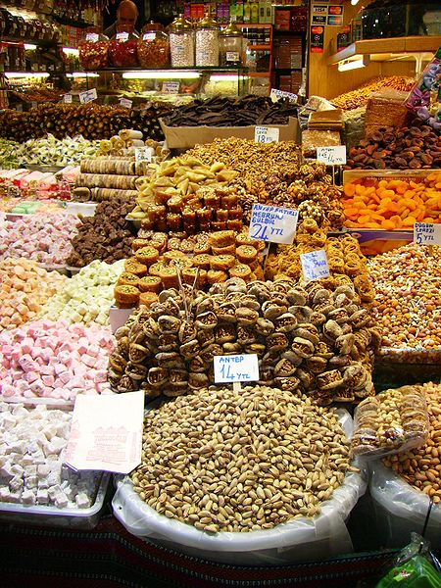
Morning departure for Denizli Airport for our flight to Istanbul. Upon arrival, we will be met and escorted to our hotel. After checking in, we will have a coach bring you to the Grand Bazaar, where we will stay together for the first few hours with our guide before exploring on our own. This is the largest oriental bazaar in the world and you’ll need that guidance and maybe some help with bargaining and buying. This is not simply a building, nor a market, nor even a district, but is in truth a city, a separate urban area with its own alleys, thoroughfares and streets, a labyrinth of shops that are fascinating to explore. There are shops with windows teaming with gold and diamonds in the jewelers section of the Bazaar, where you will find jewelry in gold, silver platinum, cut diamonds, and other gems and precious stones. In one place you will see a shop in the form of a small kiosk, which was formerly the counter of a dairy; take the little spiral staircase to the upper floor and take a look at the market spreading immediately below you. Then down the stairs and to the left you will arrive at the antiquities section of the Bazaar, where you will find objects in copper and bronze, with every sort of souvenir you can imagine to tempt you… they know you are flying home, so part of the bargaining in the shipping ! The coach will return at a designated time and place to return you to the hotel, or you can make your own way back to relax a bit before our Farewell Dinner. Overnight Istanbul. Hotel Eresin Taksim or similar

Day 9, Thursday, September 22: Transfer from hotel to Airport (B)
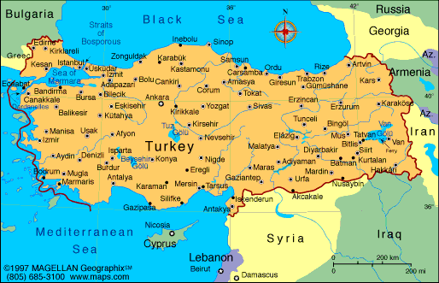
Transfer to the airport for your flight to Istanbul for your flights back home.
CONFIRMED HOTELS 4-Star
Istanbul (2 nights) - Hotel Eresin Taksim or similar
Cappadocia (1 night) - Hotel Perissia or similar
Kusadasi (2 nights) - Hotel Tailises or similar
Denizli (1 night) - Hotel Denizli or similar
Istanbul (1 night) - Hotel Eresin Taksim or similar

Program Pricing & Considerations
Double Occupancy $2,195.00
Single Room supplement $ 350.00
Air Taxes and Fuel Supplement charges $ 287.00
Pre-paid Gratuities - $90.00

Shortfall Supplement – Pricing is based on 20 person trip
15 –19 guests – $150.00 per person
10- 14 guests – $300.00 per person

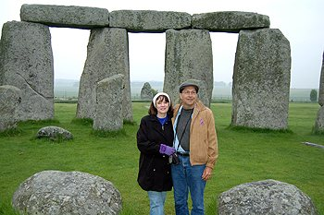
Rev. Cindy Fuller and Rev. Patrick Abent are the founders of Inner Quest…
and have been serving full time at the church since its inception. Their dedication to Spirit and their willingness to “work fearlessly” has created an environment of healing, truth and support for every individual. They have served tirelessly to “prove” the laws and create a space of heaven on earth.

Inviting you to share this important Seminary Program to Turkey

Sept. 14 – 22, 2011

Please make the following reservations. A separate registration is needed for each traveler

Name (as on passport): ______________________________________________ Date ______________
Address: _______________________________ City: ____________________ State: ______ Zip:______

Day Phone: ( )_____________ Evening Phone:( ) ____________ Email;________________________
Wishing to room in double with: ___________________________________ (or) Single Supplement (___)
[ ] I am physically capable of managing the physical requirements of the itinerary as stated OR
[ ] I will need Special Assistance to participate with this group: Please state physical limitations: _________
__________________________________________. Some assistance may be subject to additional charge.

My passport is from what country _____ Passport # _________________________ Issued Date _______
Cash Payment:
[ ] Enclosed is my deposit of $500 check, I understand that the balance will be invoiced, and will be paid by July 14th, 2011 – and subject to the terms and conditions for refunds. Until that date, all but $100.00 registration fee is refundable.
Credit Card Payments:
[ ] I authorize Innerquest to charge my credit card this $500.00 deposit, and I will make future and final payment arrangement based on the terms and conditions set forth below
.
[ ] I authorize Innerquest to charge my credit card $ 500.00, and make monthly withdrawals of $_______
so that my full payment has been made by July 14th, 2011
Card Number_________________________________ Expiration Date______ Authorization Code:______
Name on card (if different than above) ______________________________________________________

Address on card (if different then above) ____________________________________________________

Signature_______________________________________________________ Date: ________________

Please make a copy of this completed form for your records, with my signature on this application, I agree that I have read and understand the reservation, cancellation, return policies, and all terms and conditions.

TERMS & CONDITIONS
Innerquest & Body Mind, Spirit Journeys / RMC
Seminary Program to Turkey
Sept. 14 – 22 - 2011

Reservations & Payments: A completed application must be submitted with your reservation including a deposit of $500 per person to BMSJ right away to hold your reservation. Final payment due on or before July 14, 2011.

Cancellations & Refunds: Cancellation fees are as follows: $100 non-refundable airfare fee. Additional 25% if cancellation is between 70 and 60 days; From 59 to 45 days, there is a 50% charge. Under 45 days, the charge is 100% of the tour price. We strongly suggest that you apply from trip cancellation and interruption insurance. This policy will be mailed to you by BMSJ/RMC, following the receipt and acceptance of your registration.
Trip Cancellation/Interruption Insurance: A Trip Cancellation/Interruption/Medical insurance is NOT included in the package and a brochure and details will be sent with your confirmation. BMSJ/RMC & InnerQuest strongly suggest that you purchase this policy, issued by a 3rd party independent carrier, to add this limited protect to your investment.
Revisions/Changes: There will be no charge for an initial revision. There will be a charge of $20 for each additional revision. This charge is over and above any charges imposed by airlines, hotels and/or ground operators unused transfers, meals and sightseeing tours cannot be refunded. Unused hotels nights are refunded only if they cover a minimum of three nights and only to the extent the operator receives refund from the hotels, after deducting cancellation charges levied by the hotel, if any. Requests for refund must be submitted in writing along with written proof from the hotel, to RMC within 30 days after return from trip.

Accommodations: The tour operator reserves the right to substitute hotels of similar category.
Air: All airline tickets are subject to each carrier's Terms & Conditions as to passage and cancellation fees. Tours are sold in conjunction with these approved carrier.
NOTE: Trip price based on a minimum of 20 participants. If less than 20 participants,
a shortfall surcharge will be invoiced as follows:
10 to 14 travelers @ $
15 to 19 travelers @ $

Consumer Disclosure Notice: RMC /BMSJ and/or their agents act only in capacity as agents for the passenger in all matters connected with hotel accommodations, sightseeing tours and transportation, whether by air, rail, bus, motorcar, boat or any other means and as agent holds itself free of responsibility for any damage occasioned from any cause. RMC and/or its agents will not be responsible for any damages or expenses or inconveniences caused by late departures or change of schedule of or strikes or to their conditions, nor will we be responsible for loss or damage to baggage or any of the passenger’s belongings. All prices quoted are correct at time of brochure printing. Rates are subject to currency and airfare changes. Any disputes arising out of these tours will be settled via Arbitration through the American Arbitration Association within 90 days of scheduled trip departure. All information contained herein, is assumed to be accurate on the date of printing (2/1/2011), but subject to change due to situations beyond our control, without notice.

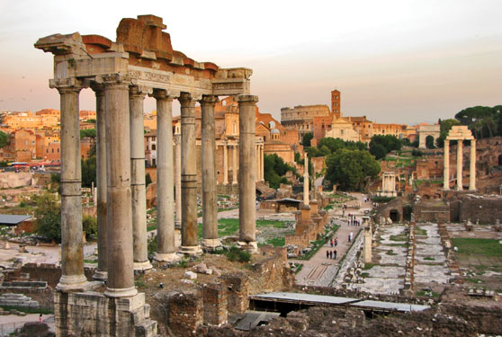
Christian Metaphysical Turkey
Innerquest Seminary Tour

Sept 14th - 22nd, 2011

Invitation by Cindy “_____________________________________________________________________
____________________________________________________________________________________
____________________________________________________________________________________
________________________________________________________________________________
Your Tour Includes:
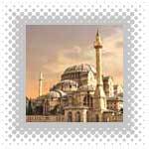
- Shuttle Service from Innerquest parking lot to and from Atlanta Airport
- Round trip flight from Atlanta to JFK
- Round trip flight JFK to Istanbul, Turkey
- Three Inter-Turkey flights, to avoid coach travel time
- Baggage handling at airports and each hotel
- Pre-paid tips and gratuities for all service providers
- First Class Hotels throughout Turkey
- All hotel taxes and service charges
- Fixed price not subject to currency exchange rates
- Daily breakfasts and dinners as per itinerary
- All ground transportation is 1st class air conditioned coaches
- Licensed guide and host throughout the journey
- All sightseeing and entrance fees as per itinerary

Added Features:
- Customized itinerary, designed exclusively by Innerquest for Seminary students
- Turkey is one of the most powerful ancient Christian Metaphysical “Power Places”
- Travel as a “private group” throughout
- Special access to Pargamon Healing Center - one of the most powerful in the world
- Special emphasis on energy temples, ancient ruins, and archeological sites
- By saving travel time with domestic Turkey flights, doing a 13-day program in 9 days
- Program designed to feel the energy at ancient sites that others only see
- A half-day at the Grand Bazaar in Istanbul… the worlds largest
Make monthly payments to InnerQuest
Base price of only $2,195.00
based on participation

